Chapter 11: Building the regression model III: Remedial measures and validation

11.1 Unequal error variances remedial measures – weighted least squares

Population regression model:

Y_{i} = β₀ + β₁X_{i1} + … + β_{p-1}X_{i,p-1} + ε_{i}

where ε_{i} ~ ind. N(0,σ²) for i=1,…,n

Therefore Var(ε₁)=σ², Var(ε₂)=σ²,…, Var(ε_{n})=σ² and 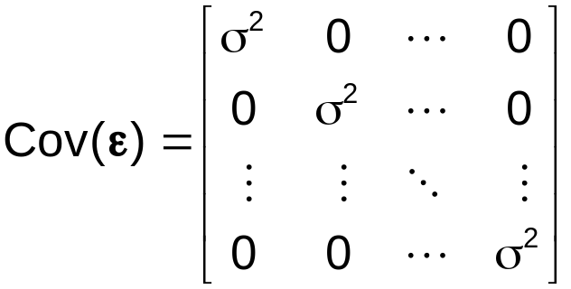.

Suppose Var(ε₁)=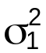, Var(ε₂)=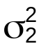,…, Var(ε_{n})=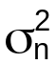 where not all of the 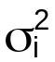 are equal. This violates the assumption of equal variances! What can be done?

Chapter 3 and 6 showed that transformations of Y can be helpful in reducing the problem.

In Chapter 11, weighted least squares estimation of the β’s is used to solve the problem.

Least squares method - Find the b₀, b₁,…, b_{p-1} such that SSE = Σ(Y_{i}-)² = Σ(residual)² is minimized where . The least squares estimators are  where
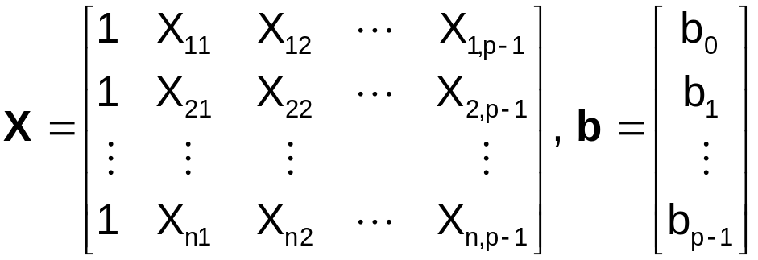, and 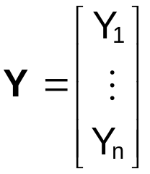.

These estimators are unbiased and have minimum variance among all unbiased estimators.

When the constant variance assumption is violated, the minimum variance property no longer holds.

What can be done?

Weighted least squares - Find the b₀, b₁,…, b_{p-1} such that SSE_{w} = Σw_{i}(Y_{i}-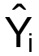)² = Σw_{i}(residual)² is minimized where w_{i}=1/. The weighted least squares estimators are  where X and Y are the same before and

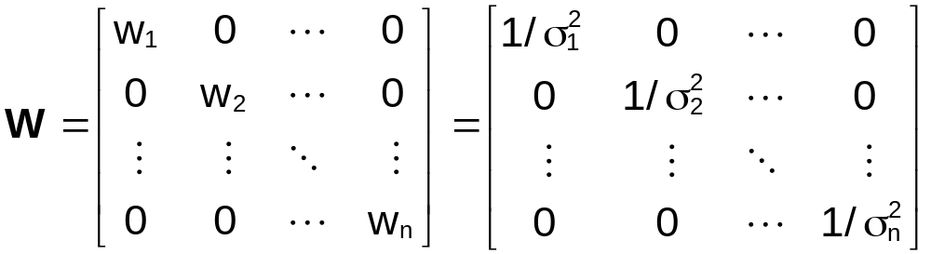

Notes:
- “w_{i}” is used to stand for weight
- See p. 429-430 #5 for a derivation of the weighted least squares estimates.
- See p. 430-1 #7 for b₀ and b₁ in simple linear regression.
- These estimators are unbiased and have minimum variance among all unbiased estimators (see the Gauss-Markov theorem – p.218 of Graybill (1976)).

Problem: w_{i}=1/ is usually unknown.

Solutions:
- If the variances are proportional to each other, then these proportions can be used to find the weights. For example, suppose =k₁σ², =k₂σ²,…, =k_{n}σ². The weights can be taken to be w_{i}=1/k_{i}.

There is still a problem with how to find the k_{i}’s.

- Suppose for each set of predictor variable values, X_{i}=(1, X_{i1},…,X_{i,p-1}), there are m_{i} different observations. Then set w_{i}=1/ where is the sample variance for the m_{i} observations.
- Examine a plot of e_{i} vs. (using regular least squares estimates). When the constant variance assumption is violated, the plot may look like:

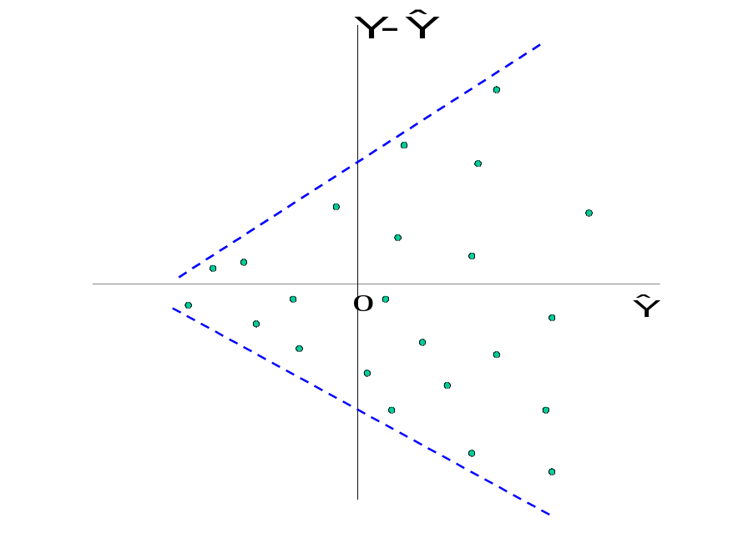
Divide the plot into 3 to 5 groups. Estimate the variance of the e_{i}’s for each group by .

Set w_{j}=1/ where j denotes the group number.
- Suppose the variance of the residuals is varying with one of the predictor variables. For example, suppose the following plot is obtained.
X_{k}
e_{i}
Fit a sample regression model using the 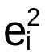 as the response variable (plays role of 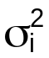 since = 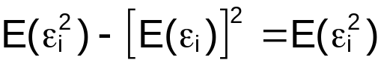) and X_{ik} as the predictor variable. The predicted values for each observation are then used to find the weights, w_{i}=1/ where denotes the estimated values.

A similar procedure can also be done using |e_{i}| to obtain estimates of σ_{i}. This is better to do with the presence of outliers.

- Consider using generalized linear models which allow for non-constant variance and other distributions for the response variable. These models are discussed in STAT 875 and 971.

Notes:
  - Inferences are usually done assuming W is known – even though it really is not. By using estimated quantities in W, there is a source of variablity that is not being accounted for.
  - R² does not have the same meaning as for unweighted least squares.
  - 

Example: Fit a regression model using weighted least squares (weighted_least_squares.R)

Below is how I simulated some data to illustrate nonconstant variance.

> #Simulate data with nonconstant variance
> X<-seq(from = 1, to = 40, by = 0.25)
> set.seed(8128)
> epsilon<-rnorm(n = length(X), mean = 0, sd = 1)
> epsilon2<-X*epsilon #Var(epsilon2) = X^2 * 1 = X^2 (non-
constant variance)
> Y<-2 + 3*X + epsilon2
> set1<-data.frame(Y,X)

> #Y vs. X with sample model
> plot(x = X, y = Y, xlab = "X", ylab = "Y", main = "Y vs.
X", panel.first = grid(col = "gray", lty =
"dotted"))
> mod.fit<-lm(formula = Y ~ X, data = set1)
> curve(expr = mod.fit$coefficients[1] +
mod.fit$coefficients[2]*x, col = "red", lty
= "solid", lwd = 2, add = TRUE, xlim =
c(min(set1$X), max(set1$X)))

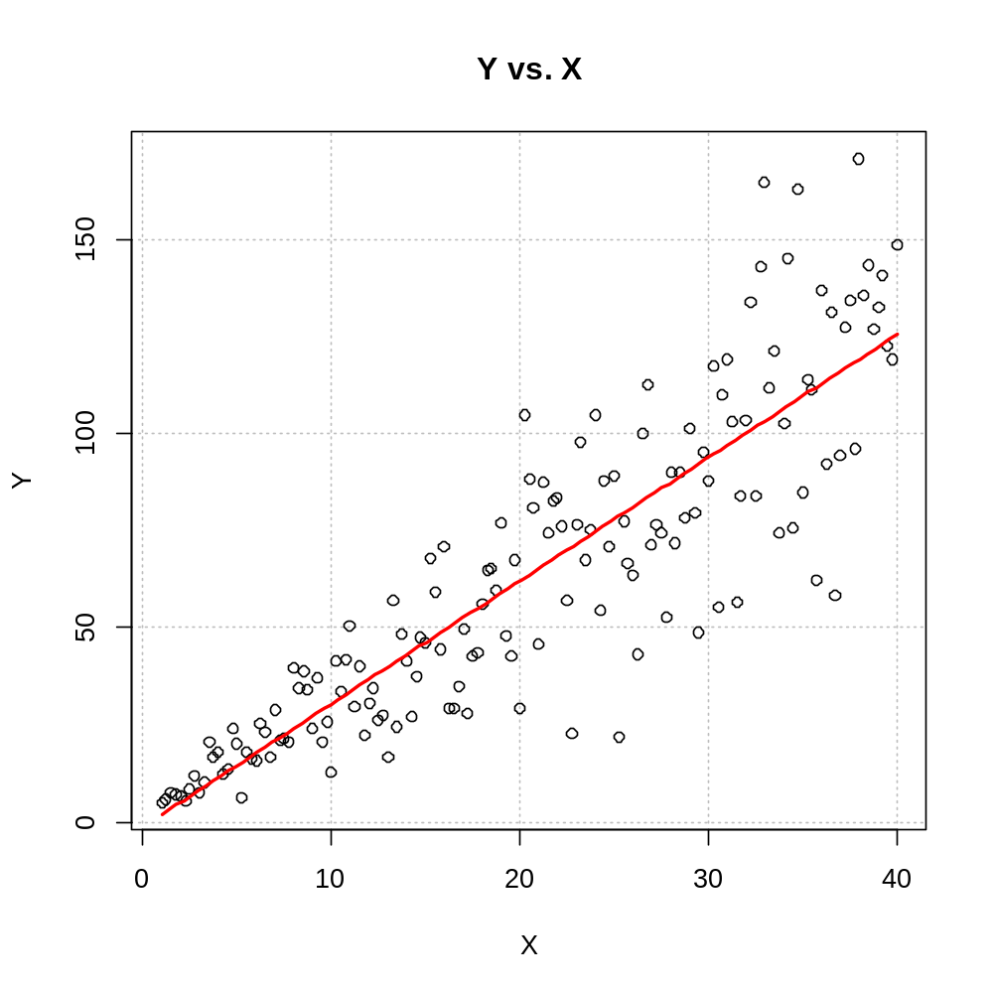

From examining the plot, one can see that the variance is a function of X.

> #Residuals vs. Y^
> plot(x = mod.fit$fitted.values, y = mod.fit$residuals,
xlab = expression(hat(Y)), ylab = "Residuals",
main = "Residuals vs. estimated mean response",
panel.first = grid(col = "gray", lty = "dotted"))
> abline(h = 0, col = "darkgreen")

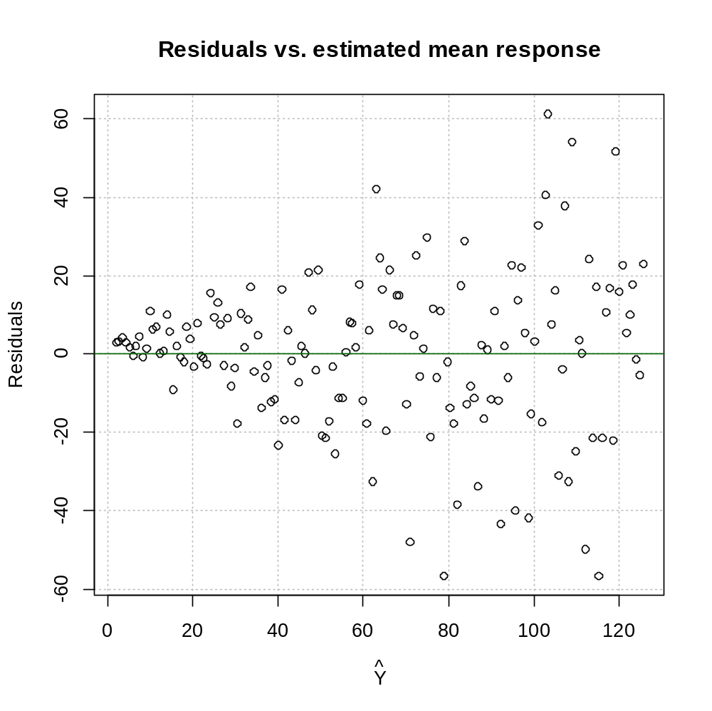

The megaphone shape above indicates nonconstant variance.

> #Try calculating a P.I. for X = 40 – will use later
> pred<-predict(object = mod.fit, newdata = data.frame(X =
40), interval = "prediction", level = 0.95)

Three different weighted least squares methods are investigated.
- Based on the predicted values, the data is broken up into 5 groups. The estimated variance for each group is obtained. The weight used is w_{j}=1/ where is the sample variance of the residuals for the m_{j} observations in group j = 1, .., 5.

> #########################################################
> # Method #1

> #Find quantiles for Y^'s
> # See R help for different ways (type) to calculate
quantiles
> quant5<-quantile(x = mod.fit$fitted.values, probs =
c(0.2, 0.4, 0.6, 0.8), type = 1)
> quant5
20% 40% 60% 80%
26.50420 51.07267 76.43366 101.00213

> #Put Y^'s into groups based upon quantiles
> groups<-ifelse(test = mod.fit$fitted.values <
quant5[1], yes = 1, no =
ifelse(mod.fit$fitted.values < quant5[2], 2,
ifelse(mod.fit$fitted.values < quant5[3], 3,
ifelse(mod.fit$fitted.values < quant5[4], 4,
5))))
> #Quick way to find the variance of residuals for each
group
> var.eps<-tapply(X = mod.fit$residuals, INDEX = groups,
FUN = var)
> var.eps
1 2 3 4 5
27.47481 149.40310 395.38512 459.77460 839.55735

> #Visualization of creating the groups
> plot(x = mod.fit$fitted.values, y = mod.fit$residuals,
xlab = expression(hat(Y)), ylab = "Residuals",
main = "Residuals vs. estimated mean response",
panel.first = grid(col = "gray", lty = "dotted"))
> abline(h = 0, col = "darkgreen")
> abline(v = quant5, col = "red", lwd = 3)

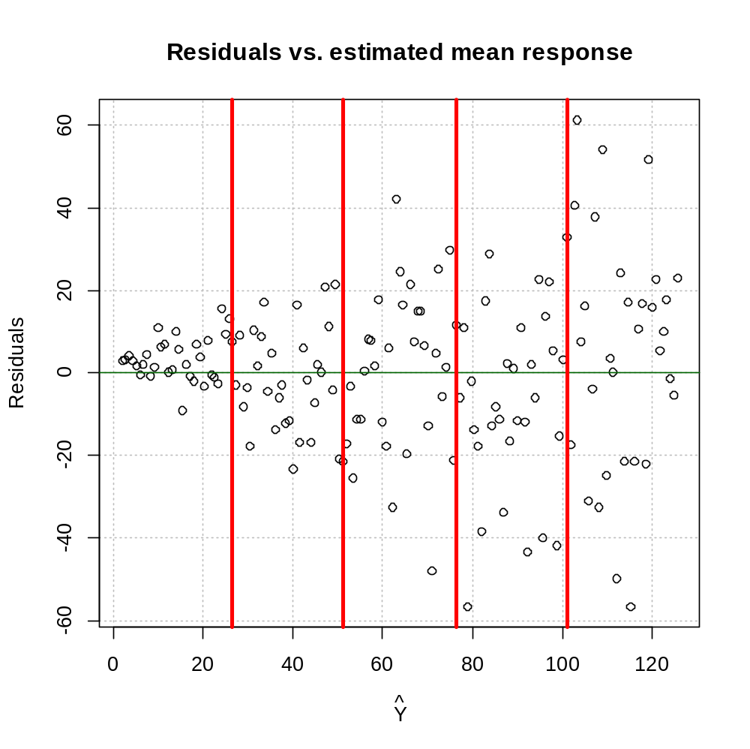

> #Put the group variances into a vector corresponding to
each observation
> group.var<-ifelse(groups == 1, var.eps[1],
ifelse(groups == 2, var.eps[2],
ifelse(groups == 3, var.eps[3],
ifelse(groups == 4, var.eps[4],
var.eps[5]))))

> mod.fit1<-lm(formula = Y ~ X, data = set1, weight =
1/group.var)
> summary(mod.fit1)

Weighted Residuals:
Min 1Q Median 3Q Max
-2.60541 -0.64240 -0.00026 0.68617 2.58652

Coefficients:
Estimate Std. Error t value Pr(>|t|)
(Intercept) 2.2916 1.2126 1.89 0.0606 .
X 2.9957 0.1051 28.51 <2e-16 ***
---
Signif. codes: 0 ‘***’ 0.001 ‘**’ 0.01 ‘*’ 0.05 ‘.’ 0.1 ‘ ’ 1

Residual standard error: 1.017 on 155 degrees of freedom
Multiple R-squared: 0.8398, Adjusted R-squared: 0.8388
F-statistic: 812.6 on 1 and 155 DF, p-value: < 2.2e-16

> #Try calculating a P.I. for X = 40
> pred1<-predict(object = mod.fit1, newdata =
data.frame(X = 40), interval = "prediction" ,
level = 0.95)

- Based on the predicted values, the data is broken up into 3 groups. The estimated variance for each group is obtained. The weight used is w_{j}=1/ where is the sample variance of the residuals for the m_{j} observations in group j = 1, 2, 3.

> #########################################################
> # Method #2

> #Find quantiles for Y^'s
> # See R help for different ways (type) to calculate
quantiles
> quant3<-quantile(x = mod.fit$fitted.values, probs =
c(1/3, 2/3), type = 1)
> quant3
33.33333% 66.66667%
43.14735 84.35897
> #Put Y^'s into groups based upon quantiles
> groups<-ifelse(mod.fit$fitted.values < quant3[1], 1,
ifelse(mod.fit$fitted.values < quant3[2], 2, 3))
> #Quick way to find the variance of residuals for each
group
> var.eps<-tapply(X = mod.fit$residuals, INDEX = groups,
FUN = var)
> var.eps
1 2 3
74.61134 404.58085 691.81087

> #Visualization of creating the groups
> plot(x = mod.fit$fitted.values, y = mod.fit$residuals,
xlab = expression(hat(Y)), ylab = "Residuals",
main = "Residuals vs. estimated mean response",
panel.first = grid(col = "gray", lty = "dotted"))
> abline(h = 0, col = "darkgreen")
> abline(v = quant3, col = "red", lwd = 3)
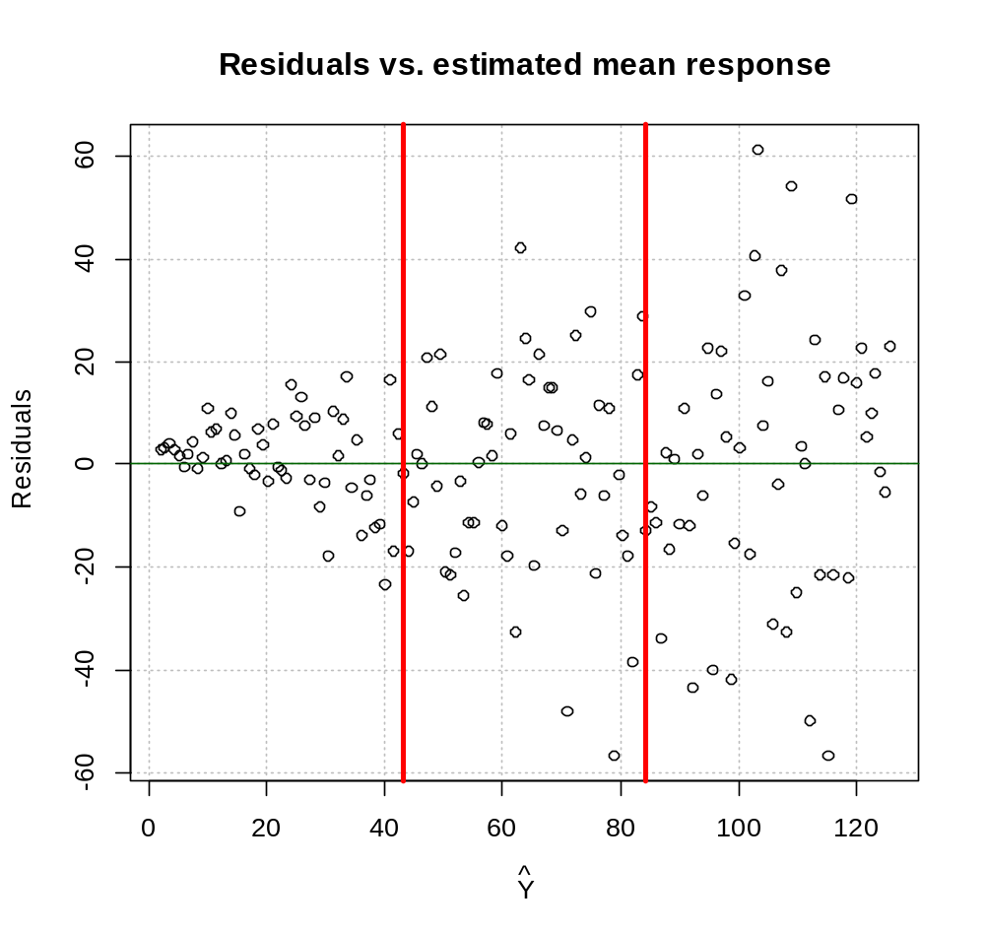

> #Put the group variances into a vector corresponding to
each observation
> group.var<-ifelse(groups == 1, var.eps[1],
ifelse(groups == 2, var.eps[2], var.eps[3]))

> mod.fit2<-lm(formula = Y ~ X, data = set1, weight =
1/group.var)
> summary(mod.fit2)

Call:
lm(formula = Y ~ X, data = set1, weights = 1/group.var)

Weighted Residuals:
Min 1Q Median 3Q Max
-2.76984 -0.57563 0.07903 0.69964 2.41329

Coefficients:
Estimate Std. Error t value Pr(>|t|)
(Intercept) 0.9033 1.7046 0.53 0.597
X 3.0446 0.1175 25.92 <2e-16 ***
---
Signif. codes: 0 ‘***’ 0.001 ‘**’ 0.01 ‘*’ 0.05 ‘.’ 0.1 ‘ ’ 1

Residual standard error: 0.9953 on 155 degrees of freedom
Multiple R-squared: 0.8125, Adjusted R-squared: 0.8113
F-statistic: 671.8 on 1 and 155 DF, p-value: < 2.2e-16

> #Try calculating a P.I. for X = 40
> pred2<-predict(object = mod.fit2, newdata =
data.frame(X = 40), interval = "prediction",
level = 0.95)

- Suppose Z~N(0,σ²). It can be shown that cZ~N(0,c²σ²). In the data simulation process, I am using ε_{i}~N(0,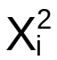σ²) as the error term where σ²=1. Thus, the most appropriate weight to use is w_{i}=1/. Of course, in a real-life data analysis setting, this information would not be known. However, this can serve here then as the “best” method to compare to methods #1 and #2.

>##########################################################
> # Method #3

> mod.fit3<-lm(formula = Y ~ X, data = set1, weight =
1/X^2)
> summary(mod.fit3)

Call:
lm(formula = Y ~ X, data = set1, weights = 1/X^2)

Weighted Residuals:
Min 1Q Median 3Q Max
-2.18635 -0.55575 0.03878 0.68580 2.36044

Coefficients:
Estimate Std. Error t value Pr(>|t|)
(Intercept) 2.04433 0.53375 3.83 0.000186 ***
X 2.97931 0.08977 33.19 < 2e-16 ***
---
Signif. codes: 0 ‘***’ 0.001 ‘**’ 0.01 ‘*’ 0.05 ‘.’ 0.1 ‘ ’ 1

Residual standard error: 0.9172 on 155 degrees of freedom
Multiple R-squared: 0.8766, Adjusted R-squared: 0.8758
F-statistic: 1101 on 1 and 155 DF, p-value: < 2.2e-16

> names(mod.fit3)
[1] "coefficients" "residuals" "fitted.values" "effects"
[5] "weights" "rank" "assign" "qr"
[9] "df.residual" "xlevels" "call" "terms"
[13] "model"

> head(mod.fit3$weights)
[1] 1.0000000 0.6400000 0.4444444 0.3265306 0.2500000 0.1975309

> tail(mod.fit3$weights)
[1] 0.0006659729 0.0006574622 0.0006491136 0.0006409229 0.0006328864
[6] 0.0006250000

> #Try calculating a P.I. for X = 40
> pred3<-predict(object = mod.fit3, newdata =
data.frame(X = 40), interval = "prediction",
level = 0.95)

> #Show some calculations without lm()
> X.mat<-cbind(1,X)
> w<-1/X^2
> W<-diag(w)
> b.w<-solve(t(X.mat)%*%W%*%X.mat)%*%t(X.mat)%*%W%*%Y
> b.w
[,1]
2.044329
X 2.979313

> mod.fit3$coefficients
(Intercept) X
2.044329 2.979313

> n<-length(Y)
> Y.hat<-X.mat%*%b.w
> MSE.w<-sum(w*(Y-Y.hat)^2)/(n-2)
> cov.b<-MSE.w*solve(t(X.mat)%*%W%*%X.mat)
X
0.28489031 -0.027742712
X -0.02774271 0.008059455

> vcov(mod.fit3)
(Intercept) X
(Intercept) 0.28489031 -0.027742712
X -0.02774271 0.008059455

Here’s an overall summary of the estimated β’s:

> #######################################################
> # Sumamrize results

> data.frame(name = c("Least Squares", "WLS 1", "WLS 2",
"WLS 3"), round(rbind(mod.fit$coefficients,
mod.fit1$coefficients, mod.fit2$coefficients,
mod.fit3$coefficients),2))
name X.Intercept. X
1 Least Squares -1.23 3.17
2 WLS 1 2.29 3.00
3 WLS 2 0.90 3.04
4 WLS 3 2.04 2.98

Since the constant variance assumption is violated, inferences using least squares estimation may be incorrect. Below are the prediction intervals for X=40.

> data.frame(name = c("Least Squares", "WLS 1", "WLS 2",
"WLS 3"), round(rbind(pred, pred1, pred2,
pred3),2))
name fit lwr upr
1 Least Squares 125.57 86.03 165.11
2 WLS 1 124.78 118.14 131.42
3 WLS 2 125.70 118.73 132.67
4 WLS 3 123.37 116.66 130.08

Notice how different the regular least squares based interval (thus, variance used in calculation) is from the WLS intervals.

11.2 Multicollinearity remedial measures – ridge regression

Some remedial measures
- Center the data for models that include quadratic terms or interactions; i.e., take X_{i}-
- Remove one of the predictor variables from the model that is causing the problem. Of course, information is lost about the removed predictor variable.
- Develop “index” variables that are linear combinations of the predictor variables. Principal components analysis produces these index variables that are uncorrelated. This topic is discussed in STAT 873.
- Ridge regression modifies the least squares method so that biased estimates are allowed that may result in more precision (smaller variability for the estimator).

Ridge Regression

Read on your own.

11.3 Remedial measures for influential cases – robust regression

Least squares estimates can be influenced by influential observations, which may lead to a distortion of the relationship between the predictor variables and the response variable.

What can be done if influential observations are present?

- Make sure a data entry error did not occur.
- Removing observations from the data set should be done rarely. This is done when the model is not intended to cover special circumstances corresponding to outlying observations.
- Robust regression is used to lessen the influence of influential observations.

Robust regression

Estimation techniques (other than least squares) are used which are not as affected by influential observations.

Least absolute residuals (LAR) regression

Minimize Σ|Y_{i}-| to find parameter estimates

Iteratively reweighted least squares (IRLS) regression

Weighted least squares estimation is used to find parameter estimates. Weights are assigned corresponding to how outlying an observation is. These weights are updated multiple times during an iterative process.

Generalized linear models are often fit using IRLS.

Least median squares (LMS) regression

Minimize median{(Y_{i}-)²} to find parameter estimates

Least trimmed squares (LTS) regression

Minimize 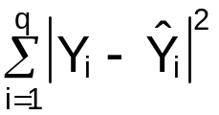 where q < n to find parameter estimates using the q smallest absolute residuals (sorry, the notation is not the best). R uses q = 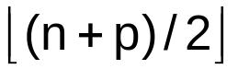

Iterative methods are often used to find these parameter estimates. Usually, equations can not be written out to find these estimates like which can be done with the least squares method.

Example: KNN p.441 (ex_p441.R)

Y = Average mathematics proficiency for a state (mathprof)

X₂ = Percent of students with several reading resources (homelib)

I will fit the model using LMS and LTS.

> table11.4<-read.table(file = "C:\\chris\\UNL\\STAT870\\
Instructor_CD\\Data Sets\\Chapter 11 Data
Sets\\CH11TA04.txt", header = FALSE, col.names
= c("state", "mathprof", "parents", "homelib",
"reading", "tvwatch", "absences"), sep = "")
> #Check first few observations
> head(table11.4)
state mathprof parents homelib reading tvwatch absences
1 Alabama 252 75 78 34 18 18
2 Arizona 259 75 73 41 12 26
3 Arkansas 256 77 77 28 20 23
4 California 256 78 68 42 11 28
5 Colorado 267 78 85 38 9 25
6 Connecticut 270 79 86 43 12 22

> mod.fit1<-lm(formula = mathprof ~ homelib, data =
table11.4)
> summary(mod.fit1)

Call:
lm(formula = mathprof ~ homelib, data = table11.4)

Residuals:
Min 1Q Median 3Q Max
-36.088 -3.505 0.394 5.256 14.389

Coefficients:
Estimate Std. Error t value Pr(>|t|)
(Intercept) 135.5559 18.2641 7.422 6.65e-09 ***
homelib 1.5596 0.2265 6.886 3.51e-08 ***
---
Signif. codes: 0 '***' 0.001 '**' 0.01 '*' 0.05 '.' 0.1 ' ' 1

Residual standard error: 8.916 on 38 degrees of freedom
Multiple R-Squared: 0.5551, Adjusted R-squared: 0.5434
F-statistic: 47.42 on 1 and 38 DF, p-value: 3.508e-08

> mod.fit2<-lm(formula = mathprof ~ homelib + I(homelib^2),
data = table11.4)
> summary(mod.fit2)

Call:
lm(formula = mathprof ~ homelib + I(homelib^2), data = table11.4)

Residuals:
Min 1Q Median 3Q Max
-33.6282 -2.0086 0.7063 4.1659 11.6046

Coefficients:
Estimate Std. Error t value Pr(>|t|)
(Intercept) 530.64247 184.13496 2.882 0.00655 **
homelib -8.60404 4.72055 -1.823 0.07644 .
I(homelib^2) 0.06491 0.03011 2.155 0.03771 *
---
Signif. codes: 0 '***' 0.001 '**' 0.01 '*' 0.05 '.' 0.1 ' ' 1

Residual standard error: 8.517 on 37 degrees of freedom
Multiple R-Squared: 0.6048, Adjusted R-squared: 0.5834
F-statistic: 28.31 on 2 and 37 DF, p-value: 3.483e-08

> examine.mod.multiple.final(mod.fit.obj = mod.fit1,
first.order = 1)
Only some of the plots are shown below:

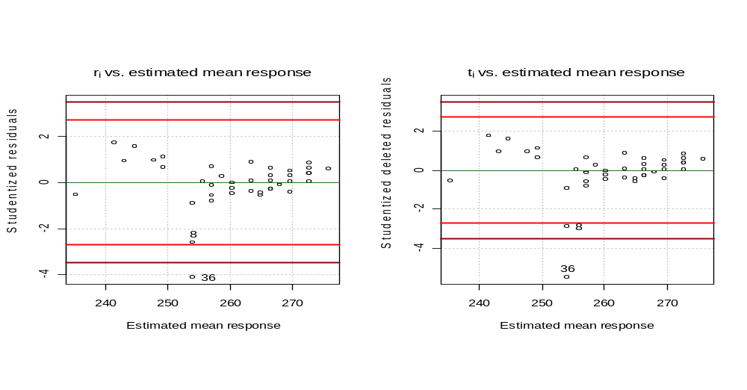

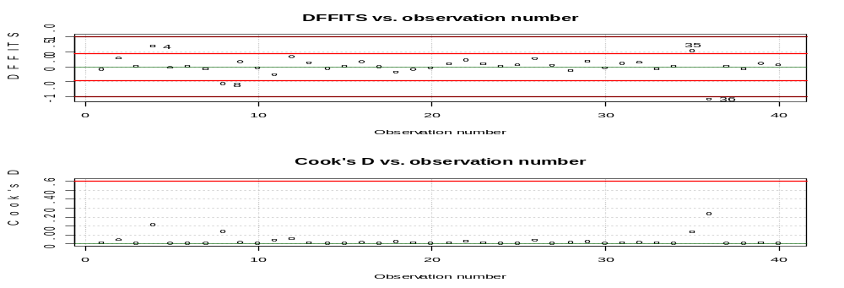

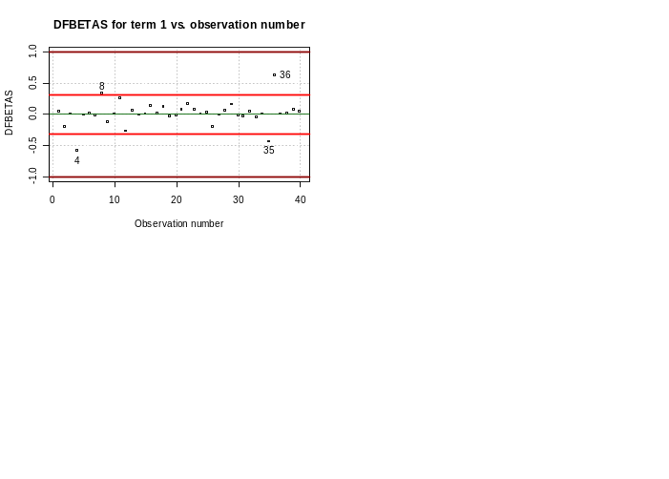
> table11.4[c(4,8,35,36),]
state mathprof parents homelib reading tvwatch absences
4 California 256 78 68 42 11 28
8 D.C. 231 47 76 24 33 37
35 Texas 258 77 70 34 15 18
36 Virgin_Islands 218 63 76 23 27 22

> examine.mod.multiple.final(mod.fit.obj = mod.fit2,
first.order = 1)

Only some of the plots are shown below:
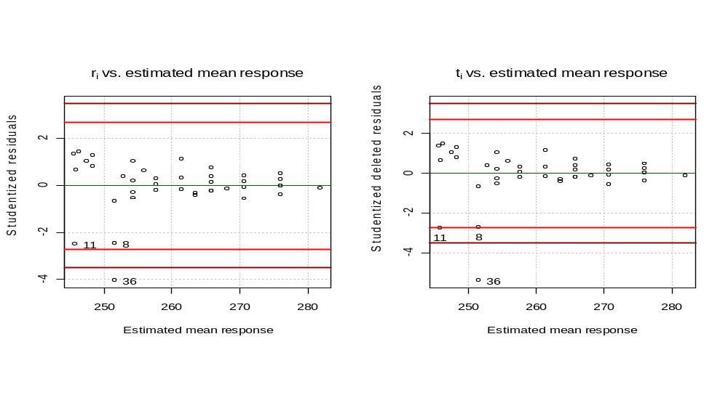
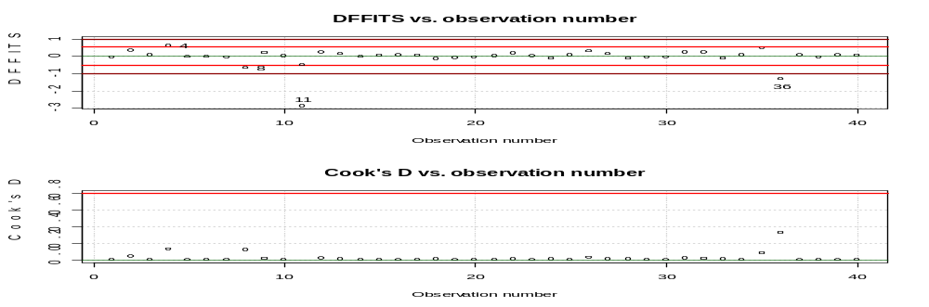
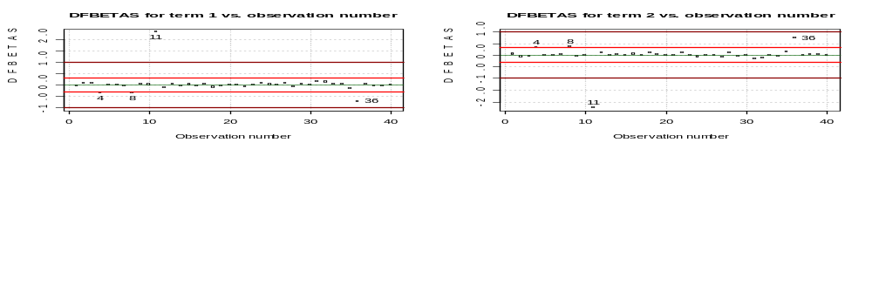

> table11.4[c(4,8,11,36),]
state mathprof parents homelib reading tvwatch absences
4 California 256 78 68 42 11 28
8 D.C. 231 47 76 24 33 37
11 Guam 231 81 64 32 20 28
36 Virgin_Islands 218 63 76 23 27 22

It looks like we may have some influential observations. Examine the plot below of the models from a least squares fit.

> plot(x = table11.4$homelib, y = table11.4$mathprof, xlab
= "homelib (% with 3 or more reading materials)",
ylab = "mathprof (mathematics proficiency)", main =
"mathprof vs. homelib", panel.first = grid(col =
"gray", lty = "dotted"))
> curve(expr = mod.fit1$coefficients[1] +
mod.fit1$coefficients[2]*x, col = "red", lty
= "solid", lwd = 2, add = TRUE, from =
min(table11.4$homelib), to =
max(table11.4$homelib))
> curve(expr = mod.fit2$coefficients[1] +
mod.fit2$coefficients[2]*x +
mod.fit2$coefficients[3]*x^2,
col = "darkred", lty = "dashed", lwd = 2, add =
TRUE, from = min(table11.4$homelib), to =
max(table11.4$homelib))
> identify(x = table11.4$homelib, y = table11.4$mathprof,
labels = table11.4$state)
[1] 8 11 36
> legend(locator(1), legend = c("first-order LS", "second-
order LS"), lty = c("solid", "dashed"), col =
c("red", "darkred"), bty = "n")

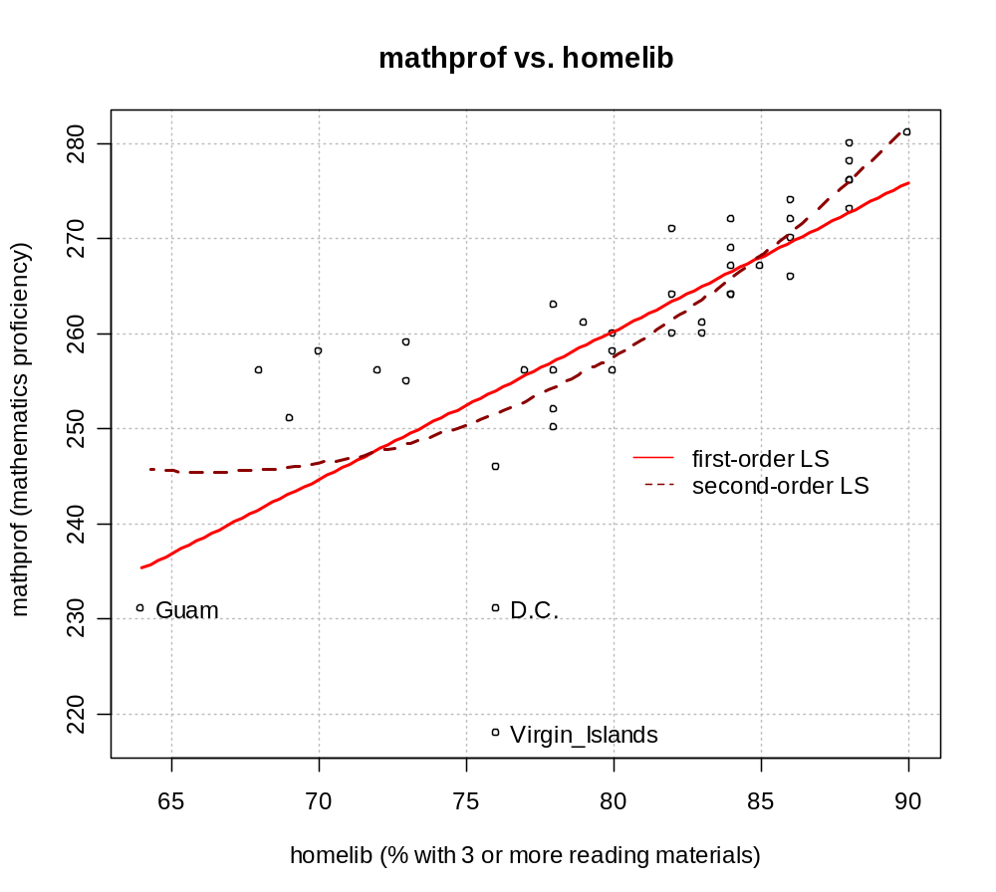

Notice there are three observations that are away from the rest. These are positions where they may be influential to a least squares method.

> #See p. 157 of Venables and Ripley (2002)
> library(MASS)

> #NOTE: SAS will minimize the 21st ordered residual where
R will do the 20th (floor((n + 1)/2)) so this is
why estimates are a little different (SAS gets b0
= 77.75 and b1 = 2.25)
> mod.fit.lms2<-lqs(formula = mathprof ~ homelib +
I(homelib^2), data = table11.4, method = "lms")
> mod.fit.lms2
Call:
lqs.formula(formula = mathprof ~ homelib + I(homelib^2), data = table11.4, method = "lms")

Coefficients:
(Intercept) homelib I(homelib^2)
829.7879 -15.6212 0.1061

Scale estimates 2.965 3.281

> summary(mod.fit.lms2) #Not helpful
Length Class Mode
crit 1 -none- numeric
sing 1 -none- character
coefficients 3 -none- numeric
bestone 3 -none- numeric
fitted.values 40 -none- numeric
residuals 40 -none- numeric
scale 2 -none- numeric
terms 3 terms call
call 4 -none- call
xlevels 0 -none- list
model 3 data.frame list

> #LTS
> mod.fit.lts2<-lqs(formula = mathprof ~ homelib + I(homelib^2), data = table11.4, method = "lts")
> mod.fit.lts2
Call:
lqs.formula(formula = mathprof ~ homelib + I(homelib^2), data = table11.4,
method = "lts")

Coefficients:
(Intercept) homelib I(homelib^2)
972.6025 -19.0952 0.1270

Scale estimates 3.444 3.613

> #Just second-order models
> plot(x = table11.4$homelib, y = table11.4$mathprof, xlab
= "homelib (% with 3 or more reading materials)",
ylab = "mathprof (mathematics proficiency)", main =
"mathprof vs. homelib", panel.first = grid(col =
"gray", lty = "dotted"))
> curve(expr = mod.fit2$coefficients[1] +
mod.fit2$coefficients[2]*x +
mod.fit2$coefficients[3]*x^2, col =
"darkred", lty = "dashed", lwd = 2, add = TRUE, from =
min(table11.4$homelib), to = max(table11.4$homelib))
> curve(expr = mod.fit.lms2$coefficients[1] +
mod.fit.lms2$coefficients[2]*x +
mod.fit.lms2$coefficients[3]*x^2,
col = "darkgreen", lty = "dashed", lwd = 2, add =
TRUE, from = min(table11.4$homelib), to =
max(table11.4$homelib))
> curve(expr = mod.fit.lts2$coefficients[1] +
mod.fit.lts2$coefficients[2]*x +
mod.fit.lts2$coefficients[3]*x^2,
col = "blue", lty = "dashed", lwd = 2, add = TRUE,
from = min(table11.4$homelib), to =
max(table11.4$homelib))
> identify(x = table11.4$homelib, y = table11.4$mathprof,
labels = table11.4$state)
[1] 4 8 11 12 35 36
> legend(locator(1), legend = c("second-order LS", "second-
order LMS", "second-order LTS"), lwd = 2, lty =
c("dashed", "dashed", "dashed"), col = c("darkred",
"darkgreen", "blue"), bty = "n")

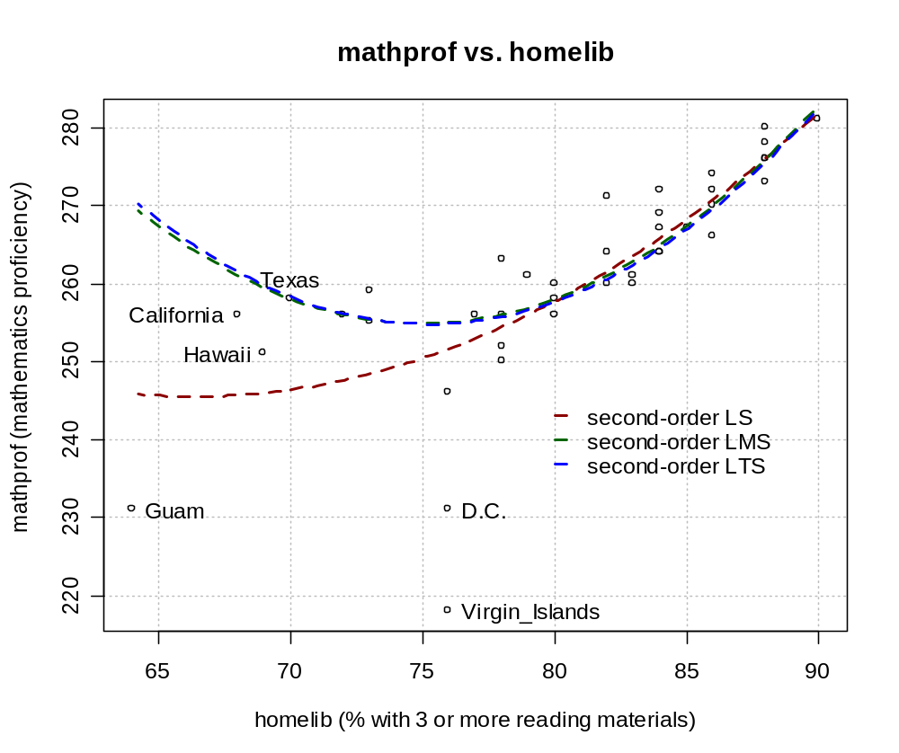

Notes:
- Notice how the LS fit model is pulled down toward the Virgin Islands, Guam, and DC observations.
- The sample regression model using the quadratic term and least squares estimation is

- The sample regression model using the quadratic term and LMS estimation is

- The sample regression model using the quadratic term and LTS estimation is

- The scale estimates serve a similar role as 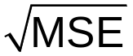 does in least squares estimation by providing an estimate of σ. See p. 874 of Rousseeuw (1984) and the R help for some information on how these estimators are calculated.
- Note that Figure 11.5 on p. 442 of KNN should have X₂ (homelib) instead of X₃ on the x-axis of those plots.

11.4 Nonparametric regression: lowess method and regression trees

This allows for fewer assumptions about the functional relationship between X₁, X₂,…, X_{p-1}, and Y.

In parametric regression (what we have been doing), the functional relationship between the predictor and response variables can be written out.

In nonparametric regression, no single expression of the functional relationship can be written out.

Summary of the lowess (loess) method for nonparametric regression

For each observation, a first-order or second-order regression model is fit to a “neighborhood” of observations around the observation. The estimate of the observation’s response variable is found using this regression model.

Consider the following plot of (X, Y) pairs:

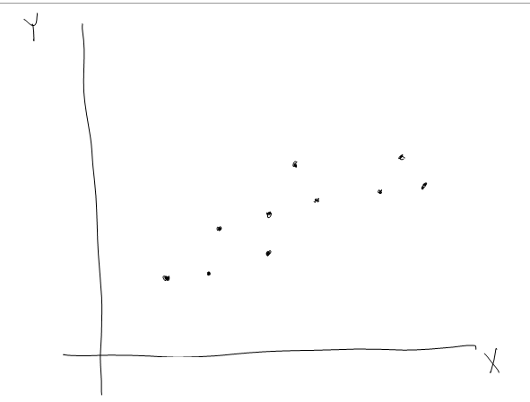

Suppose we define the “nearest neighbors” as the 3 closest observations. What are the nearest neighbors to the circled observation?

A regression model would be fit with just these observations to obtain a  for the circled observation.

The process of finding the nearest neighbors would continue for every other observation to obtain a .

As another example, suppose there are 10 observations with values (X₁,X₂,Y).

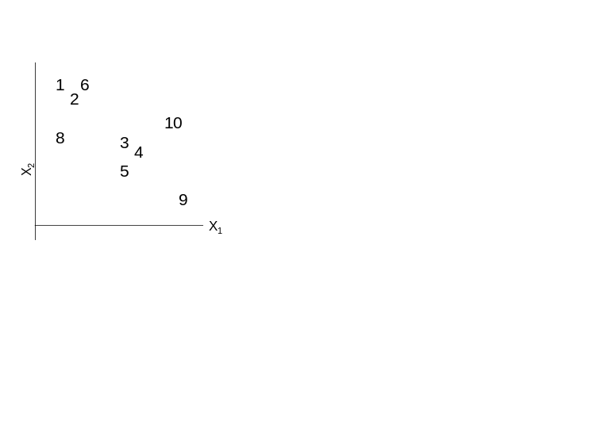

Note that Y is not shown in the plot. For observation #1, observations “close” to it are used to fit a regression model. The corresponding predicted value is the estimated value for the nonparametric regression model.

Suppose the neighborhood is defined as the 3 closest observations. Observations 2, 6, and 8 are closest to 1. A regression model is fit to these observations, and the predicted value for 1 is obtained.

This process continues for every observation.

Note that least squares methods are used to find the models for each observation. Associated inferences rely on the underlying normality assumption that one has for each observation.

Distance measure

To obtain the estimated Y_{h} value at (X_{h1}, X_{h2}), Euclidean distance is often used to measure the distance (closeness) of (X_{h1}, X_{h2}) to an observation in the data set (X_{i1}, X_{i2}):

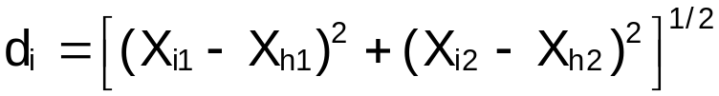

The observation, (X_{h1}, X_{h2}), does not necessarily need to be in the data set.

When predictor variables are measured on different scales, each value is scaled by its estimated standard deviation:
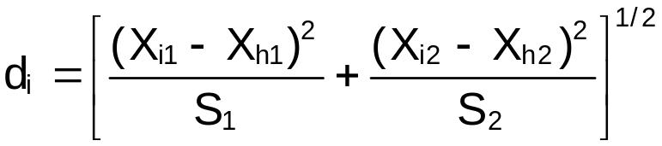

where S_{j} is the estimated standard deviation for the j^{th} predictor variable.

For more than two predictor variables, the above formula can be extended.

Weight function

Weighted least squares estimation is used to find the β estimates for each regression model. Let d_{q} denote the distance of the neighborhood’s farthest observation. The percentage of observations in the neighborhood is denoted by q. Below is the weight function:

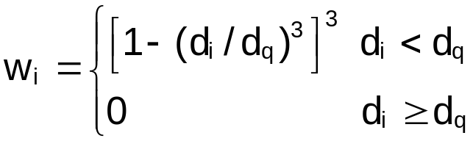

Note that 0≤w_{i}≤1. The weight function gives more weight to observations that are close to (X_{h1}, X_{h2}) and gives 0 weight to the observations that are outside of the neighborhood.

Choices of q=0.4 to 0.6 are often used. q is called the “smoothing parameter”.

After the regression model is fit for (X_{h1}, X_{h2}), the corresponding 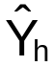 is the lowess model’s estimate of the mean response at (X_{h1}, X_{h2}). Confidence intervals for the mean response (using the normality assumption for the error terms) can also be found. These formulas are excluded.

Notes:
- Fox’s nonparametric regression online appendix provides information on R implementation (http://socserv.socsci.mcmaster.ca/jfox/Books/Companion/appendix.html).
- We have already used the lowess method before! Whenever scatterplotMatrix() was used (for example, at the end of Chapter 6), a lowess model is plotted in each plot of a scatter plot matrix to allow one to see the relationship between two variables.
- The lowess method is often called a “smoothing” procedure.
- Consider the case of one predictor variable. Why may lowess models be poor at the extremes of the predictor variable?

Example: KNN p.450 (loess_ex_p450.R)

Y = Amount of life insurance carried
X₁ = Income
X₂ = Risk aversion

> table11.7<-read.table(file =
"C:\\chris\\UNL\\STAT870\\Instructor_CD\\Data
Sets\\Chapter 11 Data Sets\\CH11TA07.txt", header =
FALSE, col.names = c("income", "risk.aversion",
"insurance"), sep = "")

> table11.7
income risk.aversion insurance
1 66.290 7 240
2 40.964 5 73
3 72.996 10 311
4 45.010 6 136
5 57.204 4 183
6 26.852 5 13
7 38.122 4 35
8 35.840 6 61
9 65.796 9 319
10 37.408 5 30
11 54.376 2 148
12 46.186 7 116
13 46.130 4 71
14 30.366 3 10
15 39.060 5 89
16 79.380 1 316
17 52.766 8 154
18 55.916 6 164

>##########################################################
> # Regular least squares

> mod.fit<-lm(formula = insurance ~ income +
risk.aversion, data = table11.7)
> summary(mod.fit)

Call:
lm(formula = insurance ~ income + risk.aversion, data = table11.7)

Residuals:
Min 1Q Median 3Q Max
-34.902 -18.471 -2.021 13.970 51.075

Coefficients:
Estimate Std. Error t value Pr(>|t|)
(Intercept) -221.5413 22.3942 -9.893 5.76e-08 ***
income 6.5080 0.4003 16.259 6.19e-11 ***
risk.aversion 6.8072 2.5601 2.659 0.0179 *
---
Signif. codes: 0 '***' 0.001 '**' 0.01 '*' 0.05 '.' 0.1 ' ' 1

Residual standard error: 23.8 on 15 degrees of freedom
Multiple R-Squared: 0.9527, Adjusted R-squared: 0.9464
F-statistic: 151 on 2 and 15 DF, p-value: 1.154e-10

> win.graph(width = 6, height = 6, pointsize = 10)
> par(mfrow = c(1,1))
> income1<-seq(from = min(table11.7$income), to =
max(table11.7$income), by = 1)
> risk.aversion1<-seq(from =
min(table11.7$risk.aversion), to =
max(table11.7$risk.aversion), by = 0.5)
> pred.data<-expand.grid(income = income1, risk.aversion
= risk.aversion1)
> save.pred<-predict(object = mod.fit, newdata =
pred.data)

> #The 3D graphing function persp() expects data to be in a format of
> # risk.aversion
> #income risk.aversion= 1.0 risk.aversion= 1.5 risk.aversion= 2.0
> # income=26.852 Pred. value Pred. value Pred. value
> # income=27.852 Pred. value Pred. value Pred. value
> # income=28.852 Pred. value Pred. value Pred. value
> save.pred.ls<-matrix(save.pred, nrow = length(income1),
ncol = length(risk.aversion1), byrow = FALSE)
> save.pred.ls[1:3, 1:3]
[,1] [,2] [,3]
[1,] -39.98078 -36.57718 -33.17358
[2,] -33.47276 -30.06916 -26.66556
[3,] -26.96474 -23.56114 -20.15754

> persp(x = income1, y =risk.aversion1, z = save.pred.ls,
theta=200, phi=20, ticktype="detailed",
xlab="Income", zlim = c(-200, 500), ylab="Risk
aversion", zlab="Insurance", expand = 1,
shade=0.5, col = "green3", main = "1st order
least squares")
> #Note that persp() is a little easier to use with the
predict() output after fitting a lowess model
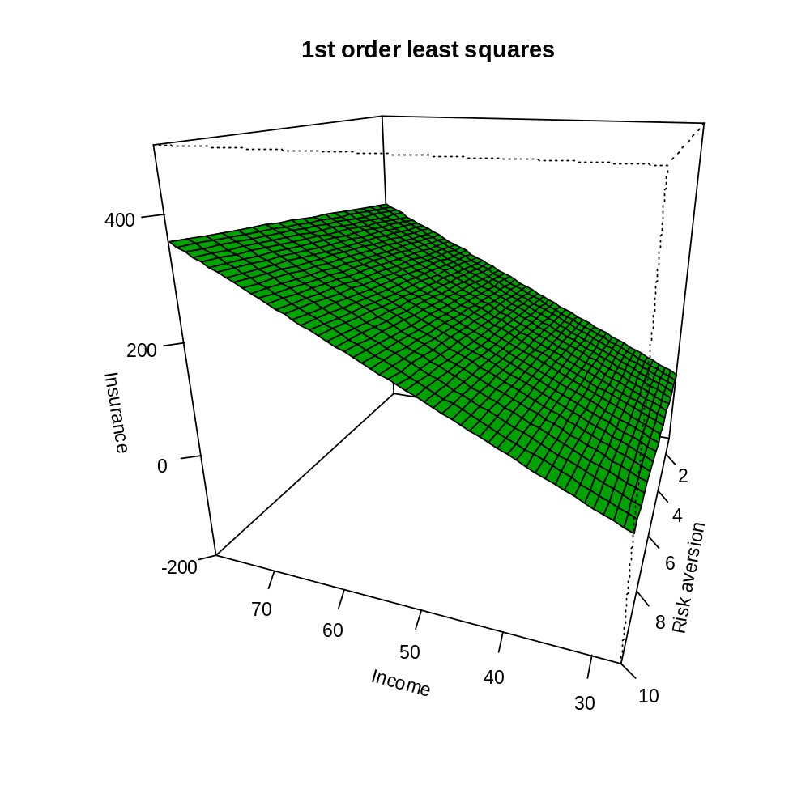
> library(Rcmdr)
> library(rgl)
> rgl.clear("all") #Clears plot window
> rgl.light() #Gray background
> rgl.bbox() #Puts numbers on plot and box around it
> scatter3d(x = table11.7$income, y = table11.7$insurance,
z = table11.7$risk.aversion, fit="linear",
bg.col="black", grid=TRUE, xlab="Income",
ylab="Insurance", zlab="Risk aversion")

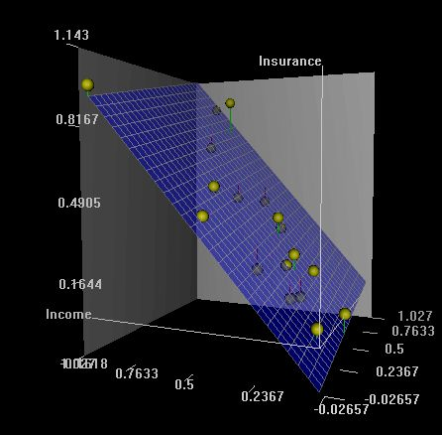

> mod.fit.loess<-loess(formula = insurance ~ income +
risk.aversion, data = table11.7, span = 0.5, degree =
1)
> mod.fit.loess
Call:
loess(formula = insurance ~ income + risk.aversion, data = table11.7, span = 0.5, degree = 1)

Number of Observations: 18
Equivalent Number of Parameters: 7.62
Residual Standard Error: 30.75

> summary(mod.fit.loess)
Call:
loess(formula = insurance ~ income + risk.aversion, data =
table11.7, span = 0.5, degree = 1)

Number of Observations: 18
Equivalent Number of Parameters: 7.62
Residual Standard Error: 30.75
Trace of smoother matrix: 10.14

Control settings:
normalize: TRUE
span : 0.5
degree : 1
family : gaussian
surface : interpolate cell = 0.2

> names(mod.fit.loess)
[1] "n" "fitted" "residuals" "enp" "s" "one.delta"
[7] "two.delta" "trace.hat" "divisor" "pars" "kd" "call"
[13] "terms" "xnames" "x" "y" "weights"

> #BE CAREFUL - Different format for resulting predictions
> save.pred<-predict(object = mod.fit.loess, newdata =
pred.data)
> persp(x = income1, risk.aversion1, z = save.pred,
theta=200, phi=20, ticktype="detailed",
xlab="Income", zlim = c(-200, 500), ylab="Risk
aversion", zlab="Insurance", expand = 1,
shade=0.5, col = "green3", main = "1st order
lowess, span=0.5")

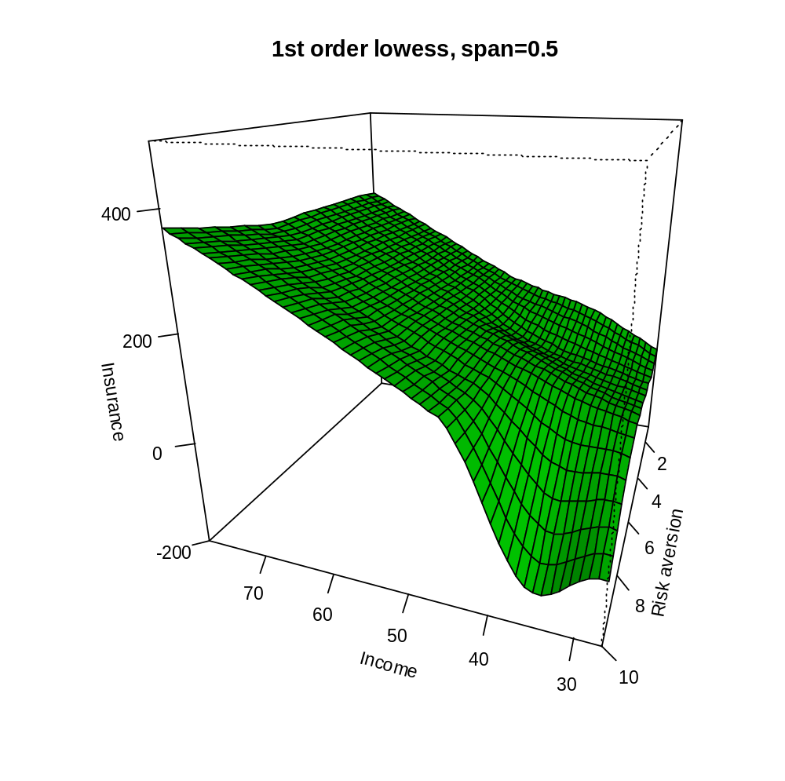

Notes:
- The loess() function (notice the spelling) fits the lowess model and provides an object of class type loess. The span option corresponds to q. The degree option specifies whether 1st order or 2nd order regression models are fit locally.
- R provides “Equivalent Number of Parameters” as 7.62. To understand where this is coming from, note the following:
  -  for regular least squares regression
  - 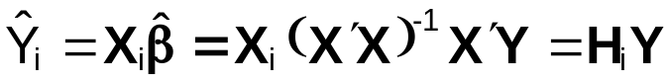 for one observation in regular least squares regression (H_{i} would be the i^{th} row of H)
  - In loess regression, notice we have a similar set up. For each observation i,  where L_{i} is used to differentiate this case from regular least squares. This leads to .

In regular least squares, we have seen earlier that 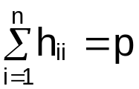. Since H is symmetric idempotent, p = tr(H′H) as well. Using a similar result, the “Equivalent Number of Parameters” is tr(L′L). With this information, a MSE can be found using SSE/(n – # of parameters). R gives a value of = 30.75 for the loess model.

- The summary() function when used with a object of type loess does not provide much more useful information than just through printing the object itself.
- Please note the form of the data in order to use the persp() function. The theta and phi options in the function control the rotation and tilt, respectively, of the plot.
- Below is plot of the two models and two additional ones to allow for comparisons of different q (span option) values. Why does the model become more smoother as q increases?

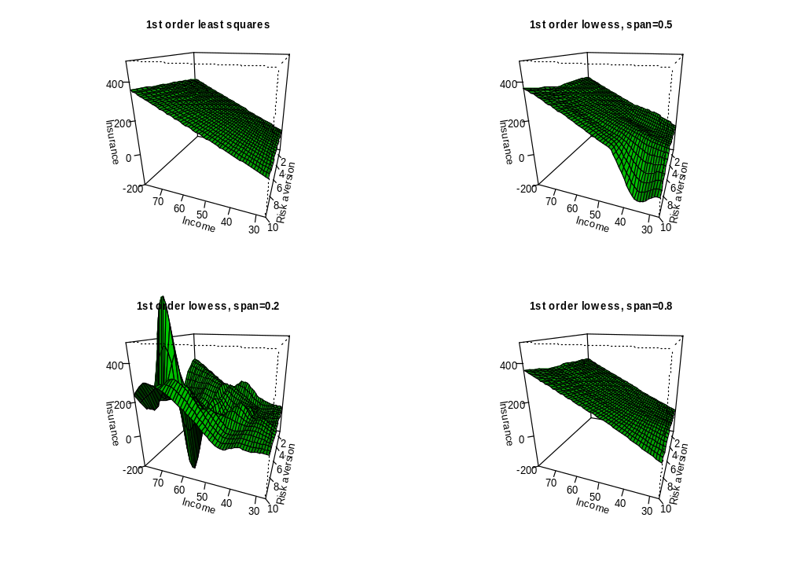
- Comparison of SSE values

> #Compare SSE values
> yhat.loess<-predict(object = mod.fit.loess)
> yhat.loess2<-predict(object = mod.fit.loess2)
> yhat.loess3<-predict(object = mod.fit.loess3)
> yhat.ls<-predict(object = mod.fit)
> sse.loess<-sum((table11.7$insurance - yhat.loess)^2)
> sse.loess2<-sum((table11.7$insurance - yhat.loess2)^2)
> sse.loess3<-sum((table11.7$insurance - yhat.loess3)^2)
> sse.ls<-sum((table11.7$insurance - yhat.ls)^2)
> data.frame(span = c("LS", 0.5, 0.2, 0.8), sse
=rbind(sse.ls, sse.loess, sse.loess2, sse.loess3))
span sse
sse.ls LS 8498.818
sse.loess 0.5 5046.228
sse.loess2 0.2 2434.523
sse.loess3 0.8 6532.778

Why do the SSE values become smaller as the q becomes smaller?

- Does the least squares model do a good job of estimating the relationship between the response and predictor variables?
- Absolute value of the residuals comparison:

> #Comparison of residuals
> plot(x = 1:length(mod.fit$residuals), y =
abs(mod.fit$residuals), pch = 1, col = "blue", lwd
= 2, xlab = "Residual number", ylab =
"|Residual|", ylim = c(-1, max(mod.fit$residuals)),
main = "Compare residuals")
> points(x = 1:length(mod.fit.loess$residuals), y =
abs(mod.fit.loess$residuals), pch = 2, col =
"red", lwd = 2)
> abline(v = 1:length(mod.fit.loess$residuals), lty =
"dotted", col = "lightgray")
> legend(locator(1), legend = c("Least squares", "Loess,
span = 0.5"), pch = c(1,2), col = c("blue", "red"),
pt.lwd = 2, bg = "white")
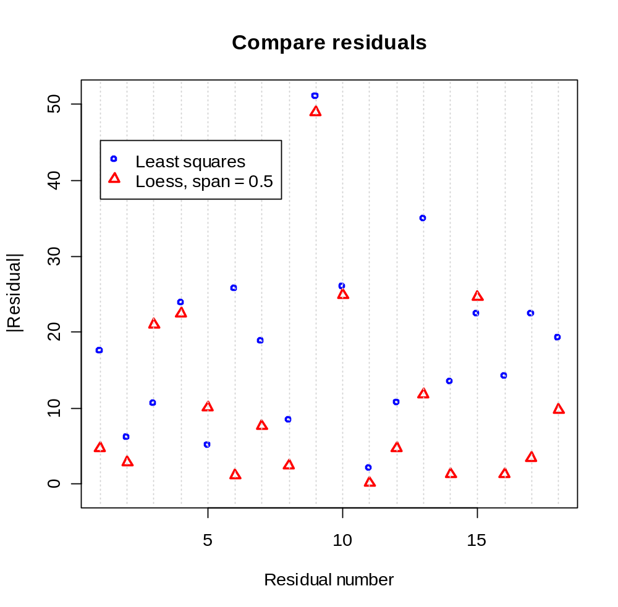

See the regression tree section in KNN on your own.

11.5 Remedial measures for evaluating precision in nonstandard situations – bootstrapping

Please see Chapter 6 of my bootstrap course notes for more information (www.chrisbilder.com/boot/
schedule.htm). Videos from this course are available as well.

11.6 Case example – MNDOT traffic estimation

Read on your own!

